Title (style Title: Arial - 12pt - bold - centered) max. 20 words
Author(s) (style NormalCentered: Arial - 11pt - plain - centered), if more than one author underline the name of the presenting author, for example: Xiuming Wang1, Jie Mao1, Dean Ta2

1Affiliation and address (style NormalCenteredItalic: Arial - 11pt - italic - centered), for example: State Key Laboratory of Acoustics, Institute of Acoustics, Chinese Academy of Sciences, Beijing, 100190, China
2Write down the affiliation and addresses of the authors, preceded by a number in superscript corresponding with their names

Text of your abstract (style Normal: Arial - 11pt - plain - justified text). Max. 400 words (keywords, figure captions, acknowledgements and references included). However, the total abstract is limited to 1 A4-page.
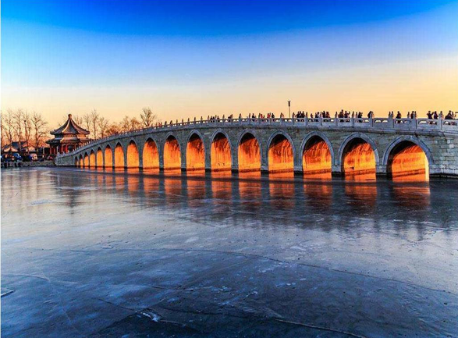
Images, pictures or graphics can be used. Please insert them directly in the text as jpeg or png figure.
Write under every image, table or graphic a short description (style Normal10pt: Arial – 10pt – plain - justified), for example: Figure 1: Summer Palace in Beijing

List of keywords (required) to be placed under the text of the abstract after the word Keywords, please use formatting as in the example below (style Normal10pt: Arial - 10pt - plain - justified text). At least 3 keywords are required.

References can be used, but please limit the number in order not to exceed the maximum of 1 A4-page. They should be placed at the end of the abstract after the word References. Please use formatting as in the example below (style Normal10pt: Arial - 10pt - plain - justified text). They should be numbered, placed in square brackets, and formatted as superscripts. Here is an example: [1]

Please do not remove empty lines present in this template. Please type your abstract directly into this document to make sure that all requirements and settings are correctly copied.
Kindly bear in mind that if your abstract does not correspond with the template, the organizers reserve the rights to reject your abstract. Please note that you can adapt your abstract until the given deadline.

Keywords
Ultrasonics, Beijing, congress

References
[1] J. Brown, F. Jackson, H. Robinson, title of source, volume number 2021, start page-end page.

